1. **Mountain Climbers Puzzle**

Formalization: [Alan Tucker](https://www.maa.org/sites/default/files/pdf/upload_library/22/Evans/november_1995_22.pdf) - Parallel Climber’s Puzzle

Story: Two hikers, Jack and Jill, want to climb the mountain range (shown in the pictures) starting from opposite sides and meet together at the highest peak. However, as they are hiking, they want to be at the same elevation at each step of the journey. Can you move Jack and Jill from the base of the mountain to the top so that they are at the same height at each moment in time?

Mathematics: This problem can be modeled using **a graph**, which is a collection of objects called vertices, and connections between them called edges. Here, we let a set of vertices represent every possible position both climbers can be at when climbing a mountain, and draw an edge between two vertices if the climbers can go from the first position on the mountain range to the second. Once drawing all the edges and vertices, if there is a **path** from the starting vertex to the top vertex, the climbers can successfully meet at the top of the mountain!… (expand explanation later)

Pictures:

Simple Range Advanced Range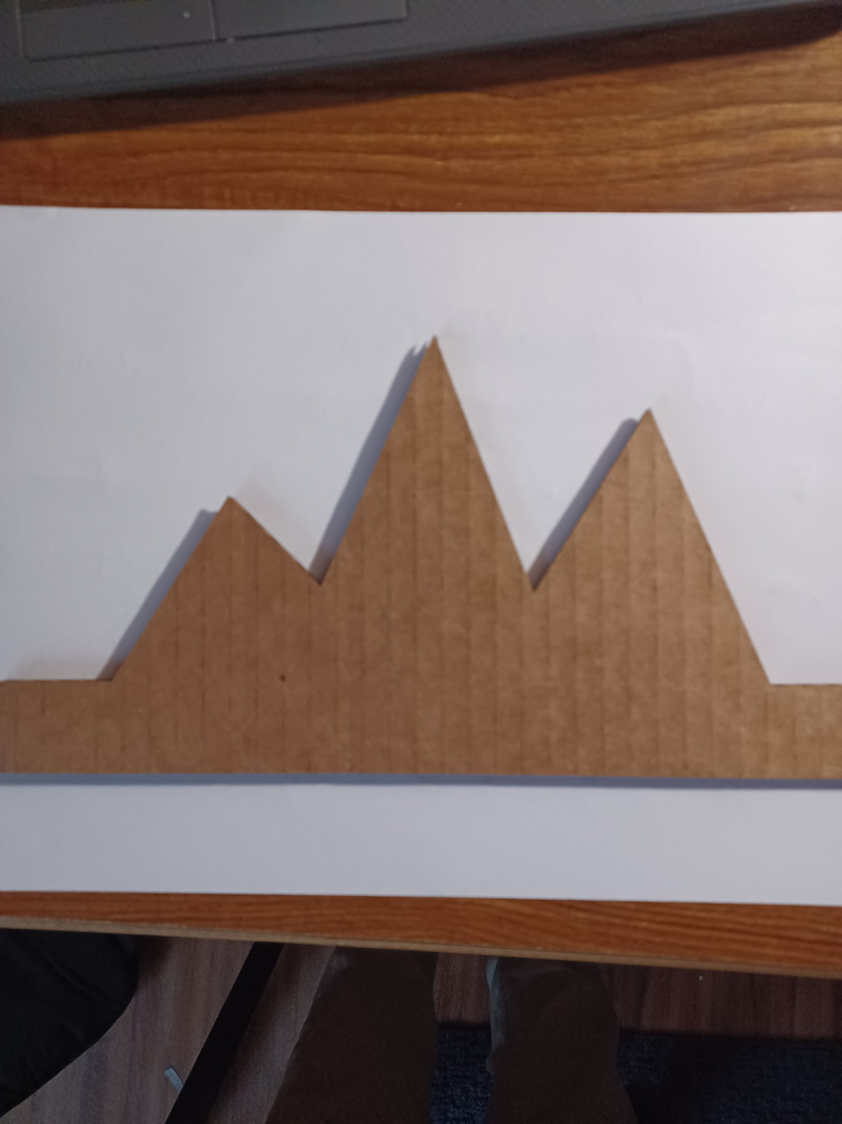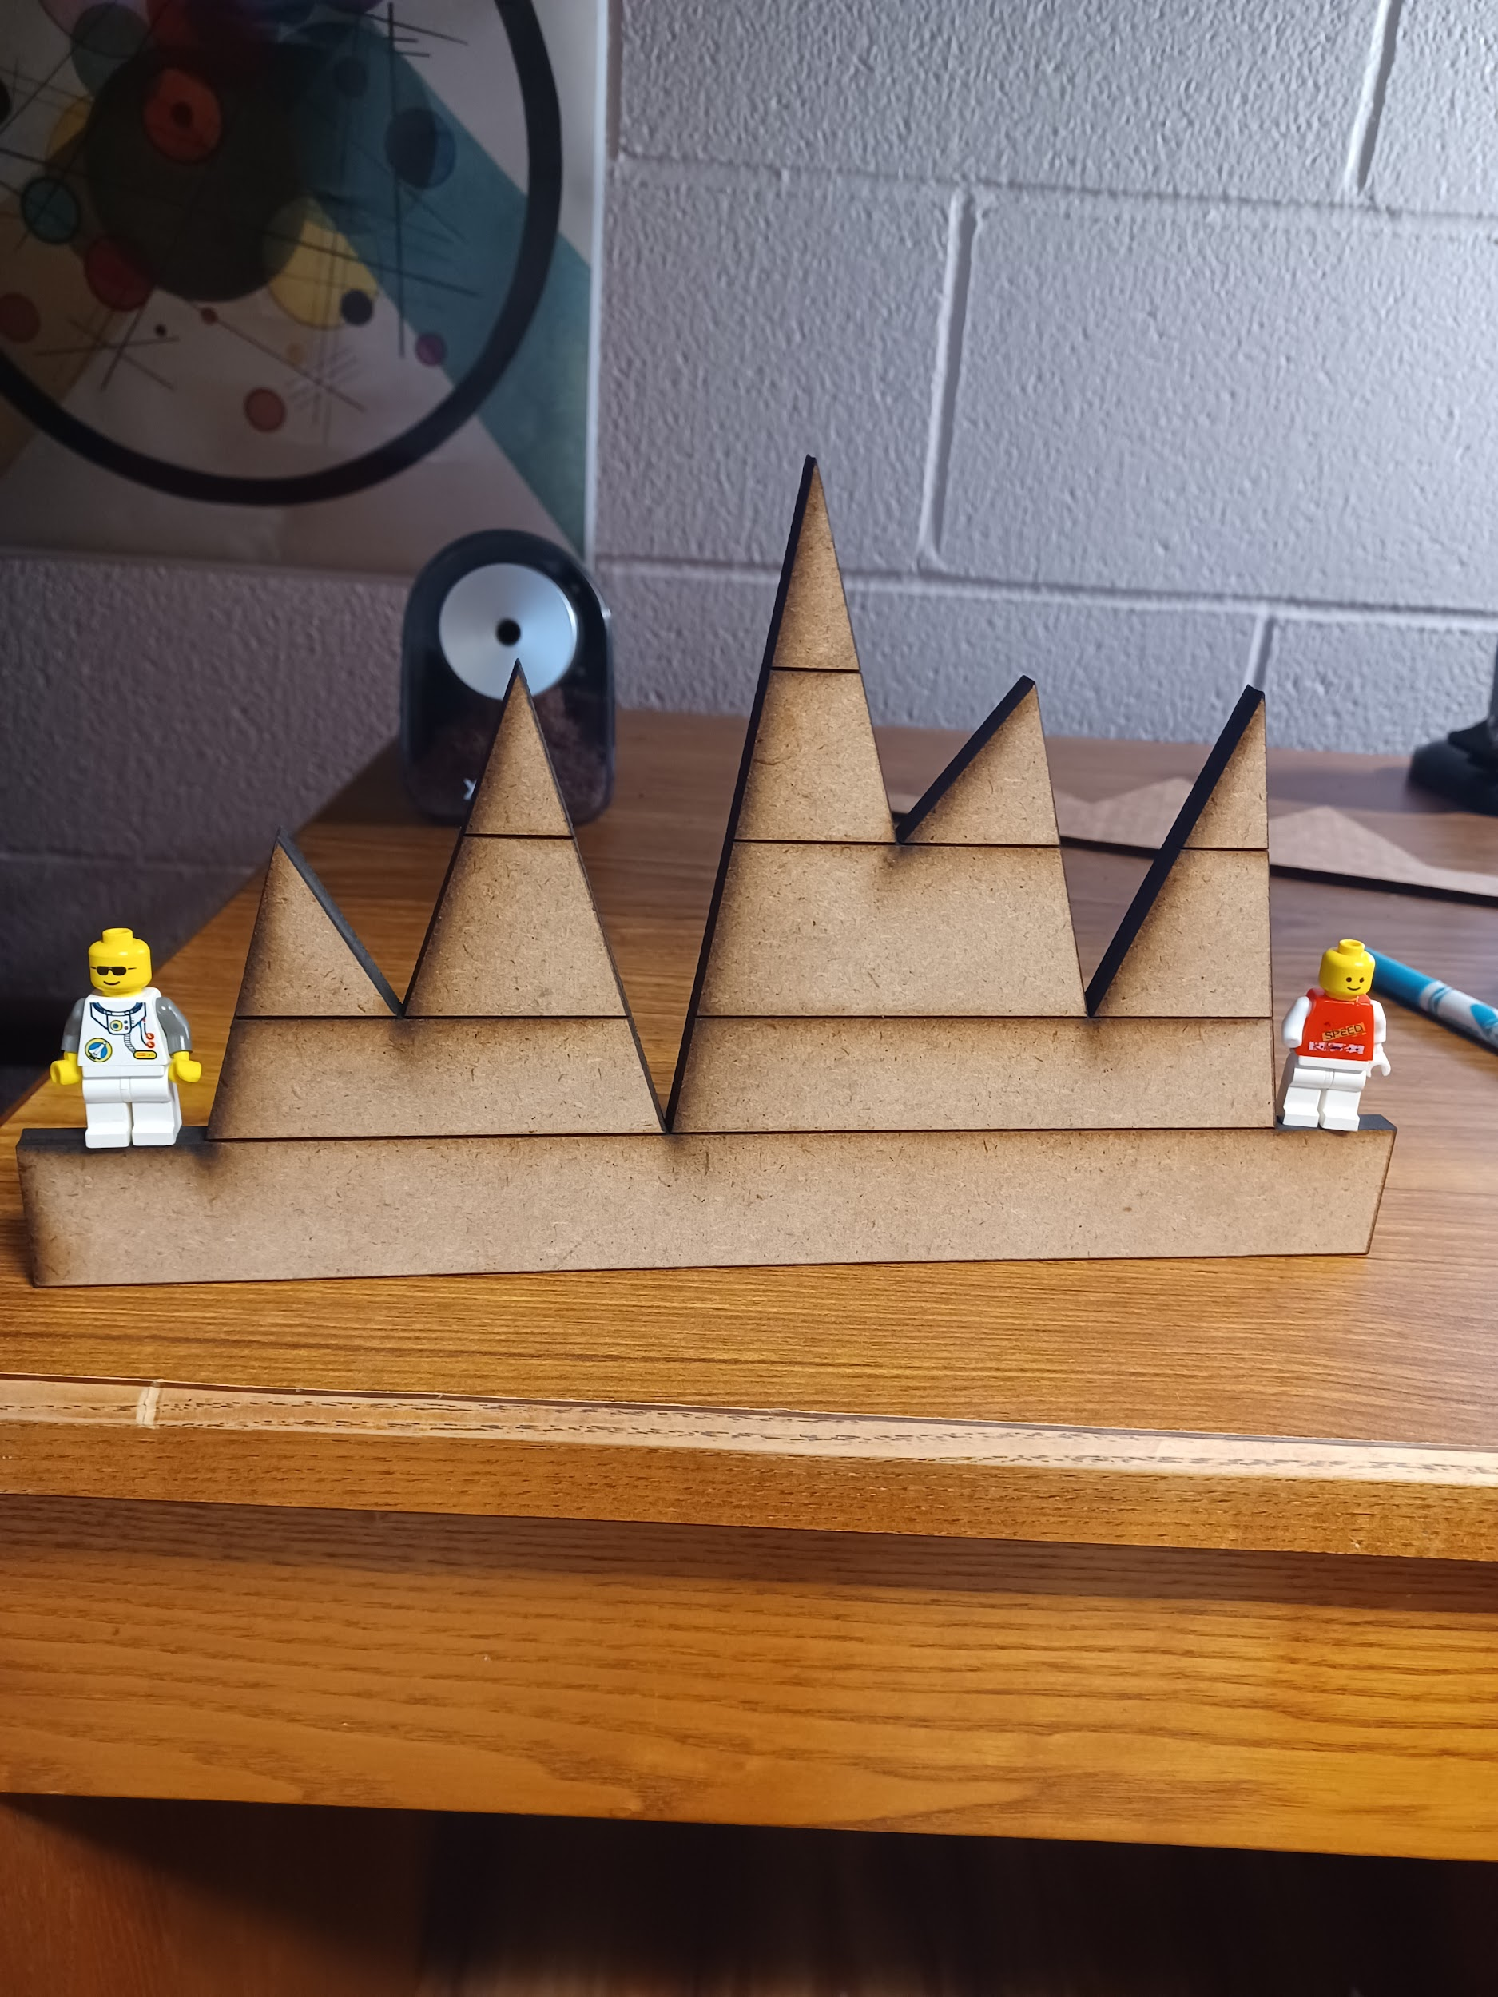

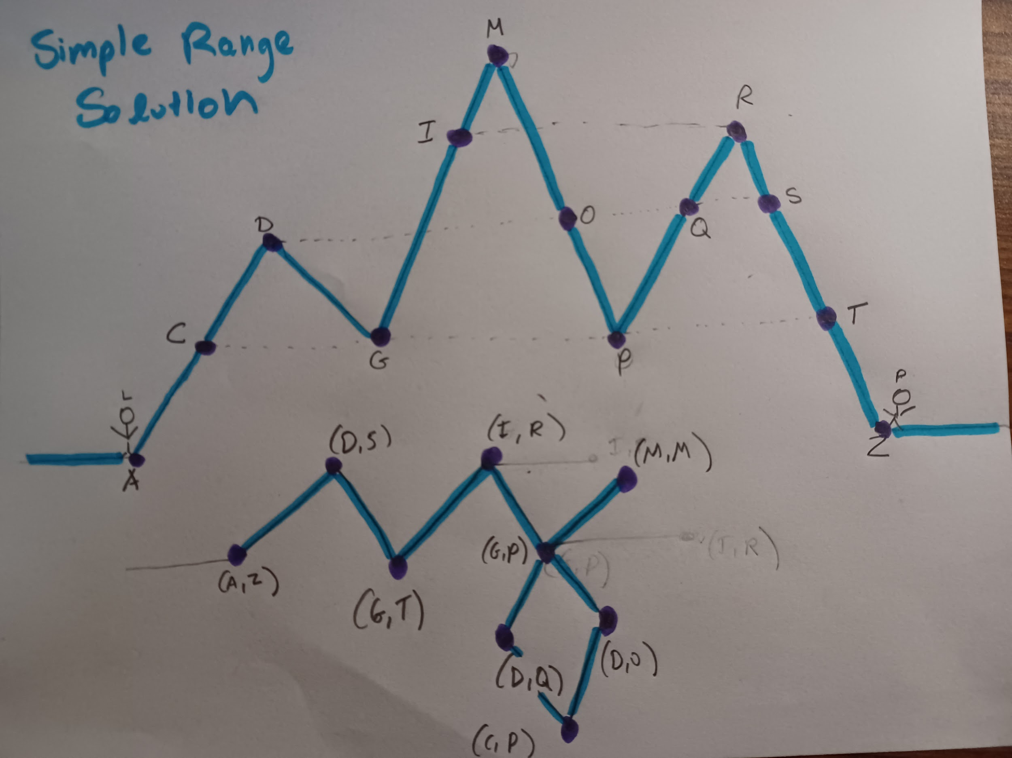

Thoughtful questions:

“How many ways can these two climbers go up the mountain?”

“How can the two climbers go up the mountain so that they travel the least distance?”

1. **Triangle Inequality**

Formalization: [Triangle Inequality](https://en.wikipedia.org/wiki/Triangle_inequality)

Story: The Triangle inequality is an important statement in algebra and geometry, stating the sum of the lengths of two sides of any triangle will always be greater than the third side length. The triangle equality can be generalized to real numbers, 2d vectors, or multidimensional normed spaces,

Mathematics:

*Geometry*

Let be a triangle, with sides of length *a,b,c.* Then,

*Algebra*

Pictures:



Ex.

Pink = a

Green = b

Purple = a - b

Notice by spinning the shorter *‘b*’ around *‘a’*, the closest *‘b*’ can get to *‘a’* is ‘*a-b*’

Therefore:

Additional Models tried out:

**25 = 24**

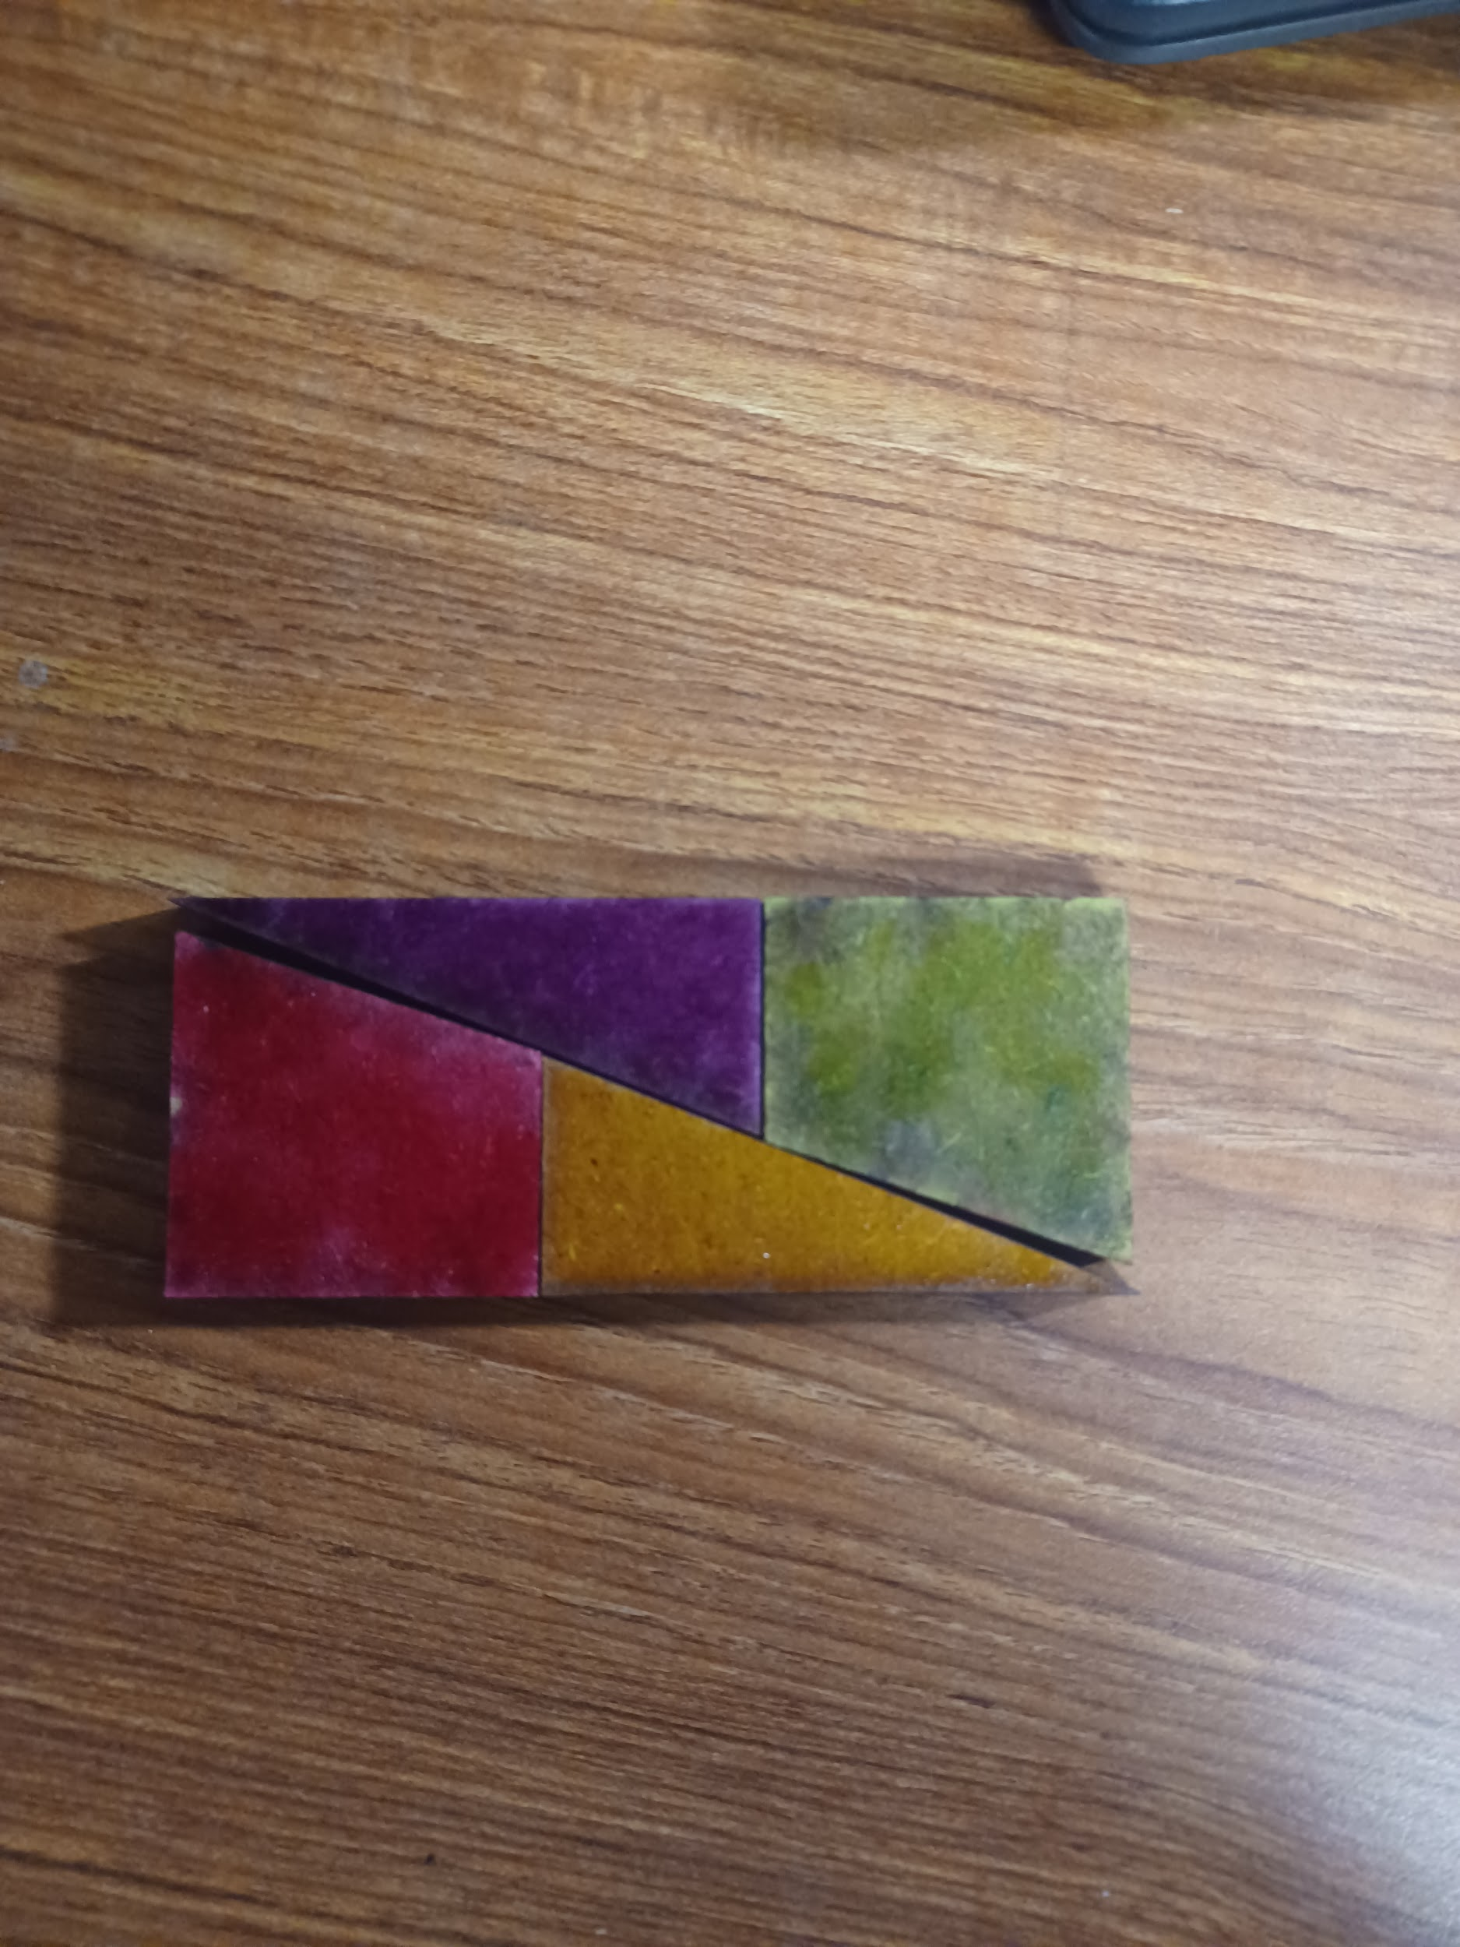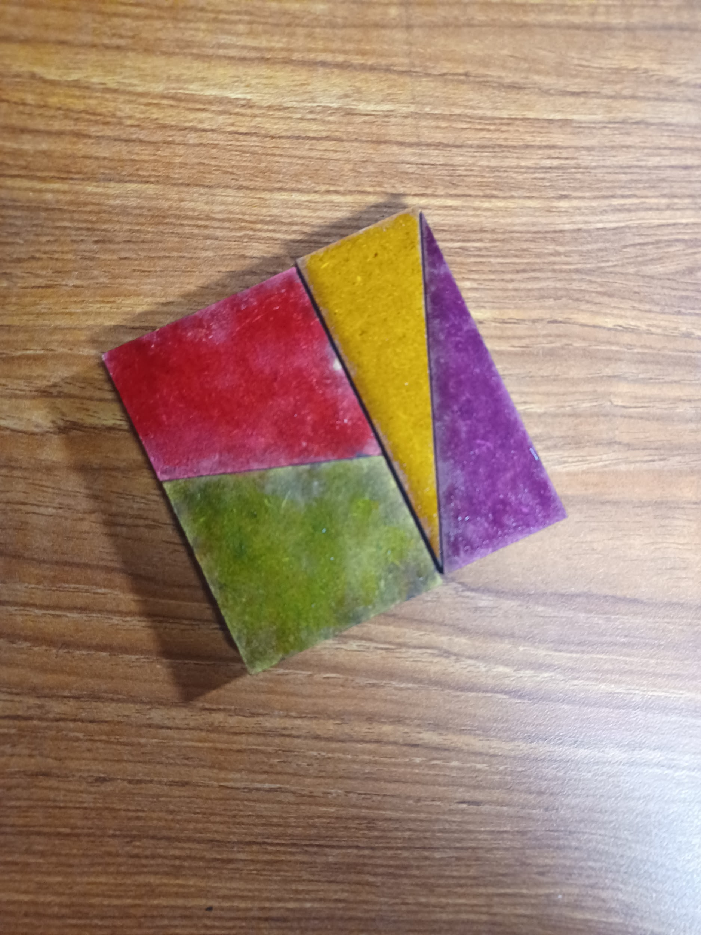

Questions:   
Where did the missing square go?

What is the slope of a triangle? Slope of trapezoid?

**Small square of primes -** Sieve of Eratosthenes

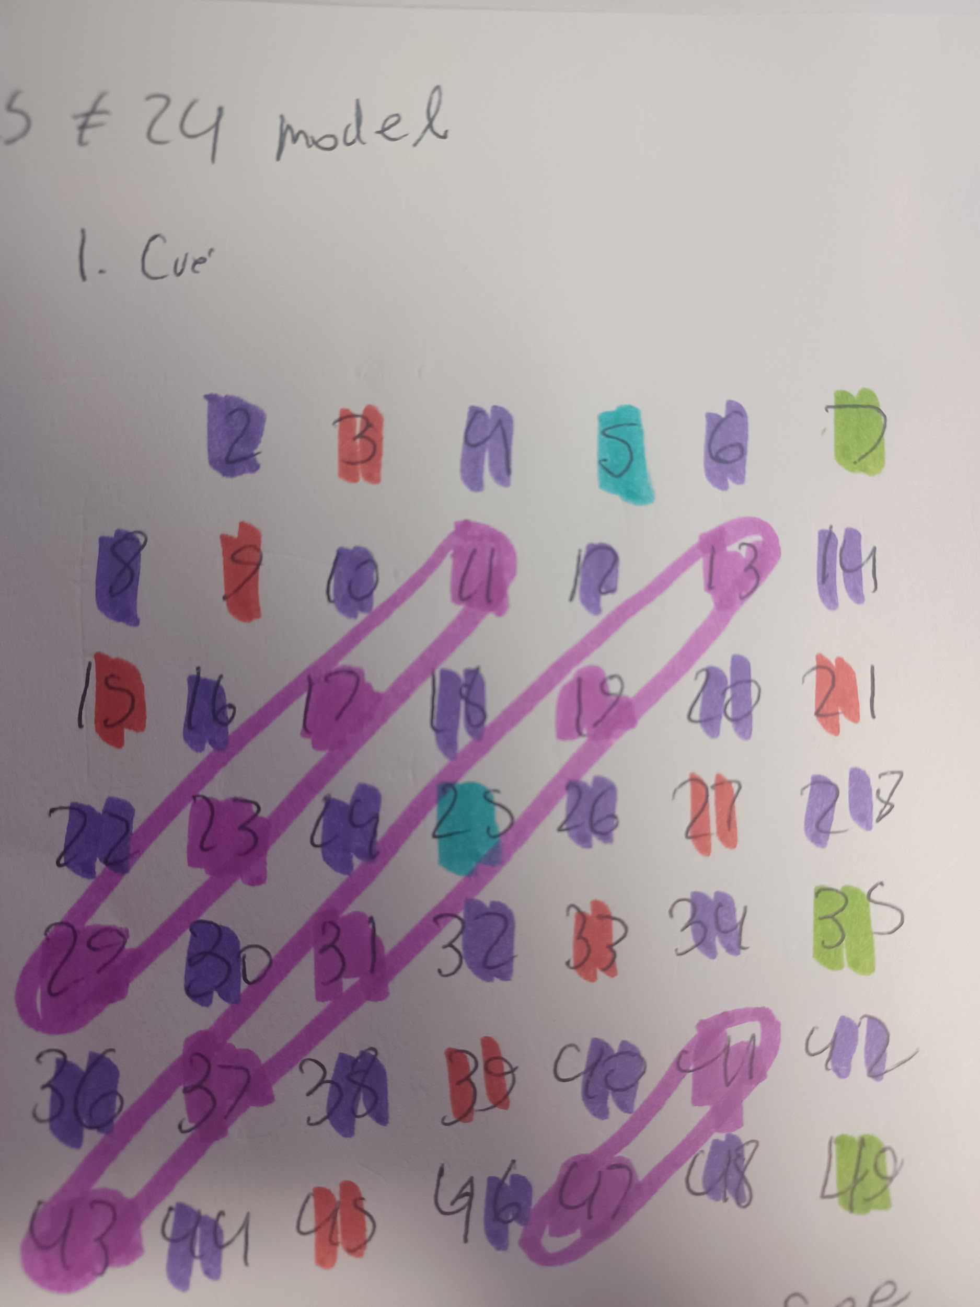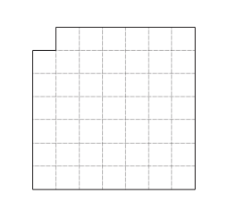

Questions:

Why do you only have to go up to 7?

Why do primes form diagonals (go around multiples of 6)?